

Master MLDM, AIMA and 3DMT - Computer Vision course

_________________________________________

Exam March 2020 - 2h without documents

__________________________________________

(4 parts with a total of 23 questions accounting for 30 points + 3 bonus points, the exam will be scored for 26 points)

Part 1 (30 mns): 3D reconstruction

Question 1 (2 points): Show how to map the coordinates of a 3D point in the scene to the coordinates of a 2D point in the image.

Question 2 (1 point): Is it possible to recover depth from a monocular point of view? Justify

Question 3 (2 points): Show how to map the coordinates of interest points in multiple 2D images of the same 3D scene viewed from different points of view.

Question 4 (1 point): Is it possible to recover depth from a binocular point of view?

Question 5 (2 points): The two images below are a stereo pair taken using parallel cameras, aligned horizontally. Describe a framework (i.e. a solution) for matching corresponding features in the two images and estimating their disparities. State clearly how your method exploits the epipolar constraint.
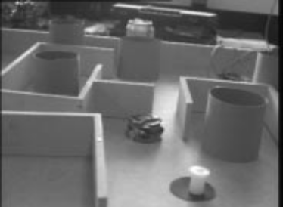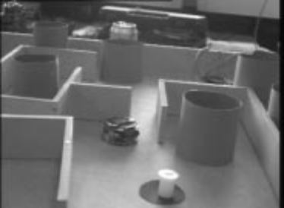

Question 6 (2 points): Explain how to obtain estimates of the 3-D positions of the objects in the scene above from stereo disparities. What information about the cameras is required for this?

Question 7 (2 points): If only one of the two images in the pair above is available, what image features might be used to make inferences about the 3-D structure of the scene?

Part 2 (20 mns): pinhole model

Question 1(1 point): What is the name of the mathematical equation of a thin lens which models the relationship between the focal f, the distance Z of a point in the scene to the camera frame and the distance z of its 2 projection in the image frame? Write this equation.

Question 2 (2 points): With the pinhole model the most distant objects appear smaller, why? With the pinhole model parallel lines in the scene can intersect in the image, show with a graphic why?

Question 3 (3 points): For the two images shown below estimate manually the positions of the three major vanishing points, corresponding to the building orientations. Do these vanishing points are located within the image plane? If yes, can we state that we have a weak or a strong perspective?

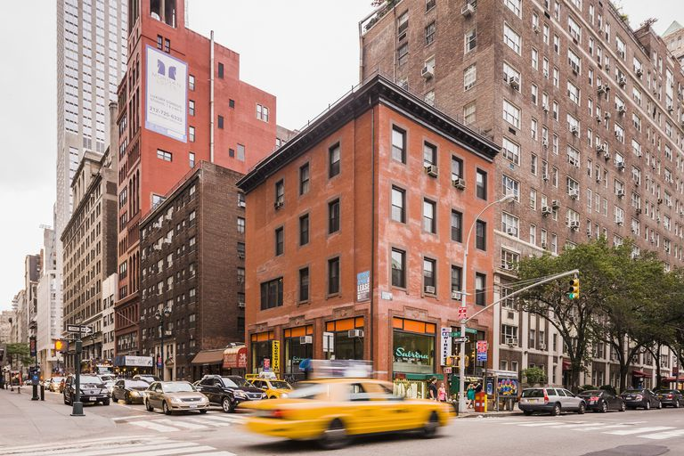

Part 3 (25 mns): In this part, we will consider a system consisting of a Time-of-Flight (ToF) camera rigidly connected with a regular, high-resolution RGB camera in a stereo setup. We will see how to calibrate the cameras, how to reconstruct 3D point clouds from the ToF depth data and how to match the depth information with the color information from the RGB camera. See hints in the Annex.

Question 1 (2 points): Explain the necessary process for determining the intrinsic camera parameters K_{rgb} and K_{tof} of the RGB and the ToF camera, respectively.

Question 2 (1 point): Explain the calibration process that is necessary as a prerequisite to relate the pixels in the ToF depth image to their corresponding pixels in the RGB image.

Question 3 (2 points): Outline how to reconstruct a metric 3D point cloud from the ToF depth data. Assume that you are given the depth d at each pixel location x = (x, y)^{T} in the ToF depth image. We would like to obtain a set of 3D points with coordinates X = (X, Y, Z)^{T}.

Question 4 (1 point): Show how to map each 3D point to the coordinate frame of the RGB camera.

Question 5 (1 point): Explain how to find the corresponding color value for each 3D point.

Part 4 (45 mns): In this part, we will consider that x = (x, y, 1)^{T} 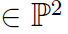and x’ = (x’, y’, 1)^{T} are the measured projections of an unknown 3D points X on the two images I₁ and I₂ from two different views of the same scene. Let F be the fundamental matric computed between the two views. Let P and P’ be the projection matrices of the two views. These two matrixes are assumed to be known exactly (or with a very good accuracy), while the measures x and x’ are supposed to be inaccurate, i.e. they do not satisfy the epipolar constraint.
^
In order to obtain a solution for the triangulation problem (i.e. finding the best estimate X of X), two corrected correspondences x and x’ have to be computed in order to minimize the geometric error:
^
^
^
^
^
^
C (x, x’) = d (x, x)² + d (x’, x’)² subject to x’ ^{T} F x = 0
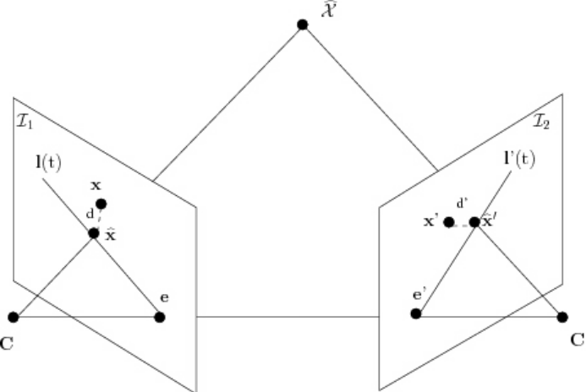
^
^
Figure 1: Unlike the measured points x and x’, the corresponding points x and x’ satisfy the epipolar constraint. The point X is chosen such that the d ² + d ’² is minimized.
^

An optimal solution can be found by using the following steps:
- Two rigid transforms are applied to the measurements and epipoles in order to simplify the equations.
- The epipolar lines in the first image are parameterized by a parameter t. An epipolar line in the image I₁ can be written as l(t).
- Using the fundamental matrix, the corresponding epipolar line l’(t) in the image I₂ is computed.
- The value of the parameter t that minimizes the cost function is estimated.

This solution is optimal if the Gaussian noise model can be assumed to be correct. In the following we will only address the first steps of this solution.

Question 1 (1 point): What are the relationships between x, x’, P, P’ and X ?

Question 2 (1 point): What is the epipolar constraint (between x and x’) ?

Question 3 (1 point): Write down the 2D projective transformation matrices T_{3x3} and T ’_{3x3} such that T_{3x3} x = x₀ = (0, 0, 1)^{T} and T ’_{3x3} x’ = x’₀ = (0, 0, 1)^{T} ? (Note that the two matrices correspond to 2D translations in order to put the measurements in the center of each image coordinate frame).

Question 4 (1 point): Give the expression of the fundamental matrix F₀ that relates x₀ and x’₀.

Question 5 (1 point): Give the equations that make it possible to compute the right epipole e= (e₁, e₂, f)^{T} and the left epipole e’ = (e’₁, e’₂, f’)^{T}.

Question 6 (1 point - bonus): If we normalize e and e’ such that e²₁ + e²₂ = e’²₁ + e’²₂ = 1, give the expression of the rotation matrices R and R’ such that R e = e₀ = (1, 0, f)^{T} and R’ e’ = e’₀ = (1, 0, f’)^{T} (Not that e₀ and e’₀ are on the horizontal axis).
Question 7 (1 point - bonus): Give the general form of the matrix F₁ = R’ F₀ R^{T} (i.e. give the value of each of its 3x3 coefficient).
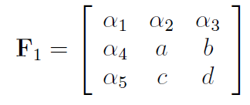

Question 8 (1 point - bonus): Give the vector representing the parameterized epipolar line l(t) in the first image I₁ passing through x ₁(t) = (0, t, 1)^{T} and e₀.

Annex

